

Test report: MCS – Data rate limit
KIT WOM 5A MIMO G2 / WOM 5A MiMo+

- General informations
Test Name | MCS – Data rate limit
Product Name | KIT WOM 5A MIMO G2 / WOM 5A MiMo+
Product Code | 4301217 / 4750238
PN Supplier | WB5nL3 / WB8nL3
Tester | Gabriel Dias dos Santos - Reliability Analyst
Segment | Enterprise Networks
Date | Feb 25, 2026
FW Version | APCPE.QM-1C.v7.8-Intelbras.20260204031117
Result | [ ] Approved [X] Disapproved [ ] Inconclusive

- Test Summary
Objective | Validate the MCS – Data rate limit
Topology: | 2 Radios + 2 computers connected by LAN port + Iperf3 SW
Operating Mode: | Bridge
Frequency | 5G
Wi-Fi Protocol | n/a
Channel | 157
Environment | Lab environment – RD

- Execution & Results
Test Case ID | Test Description | Expected Result | Actual Result | Status (Pass/Fail)
TC-01 | Select MIMO 2X2 MCS8(30) in AP and CPE, and start the throughput test | The throughput should follow the data rate (MCS) | The throughput cannot follow the data rate (MCS) | FAIL
TC-02 | Select SISO 1X1 MCS0(15) in AP and CPE, and start the throughput test | The throughput should follow the data rate (MCS) | The throughput cannot follow the data rate (MCS) | FAIL

- Observations & Technical Notes

The throughput cannot follow the data rate (MCS).
Observations
- If I defined SISO, the SNR and signal in AP is wrong:
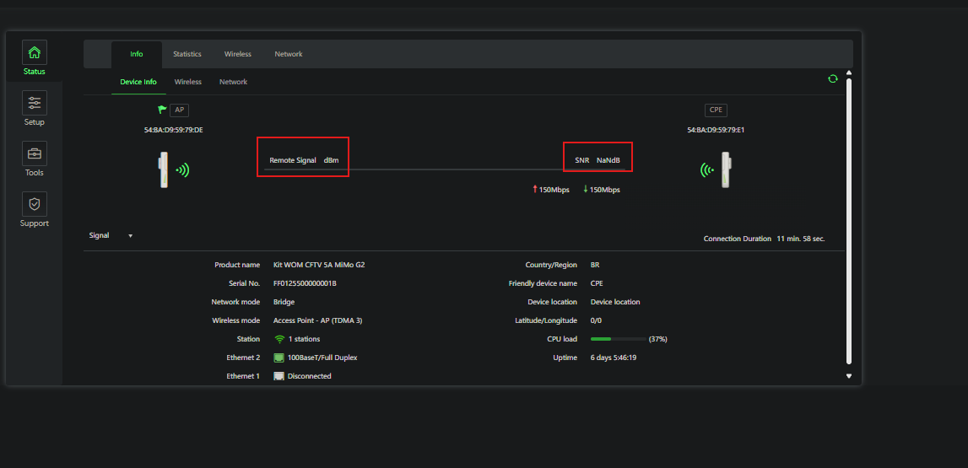

- Data rate information is wrong in the SISO and MIMO mode in AP and CPE
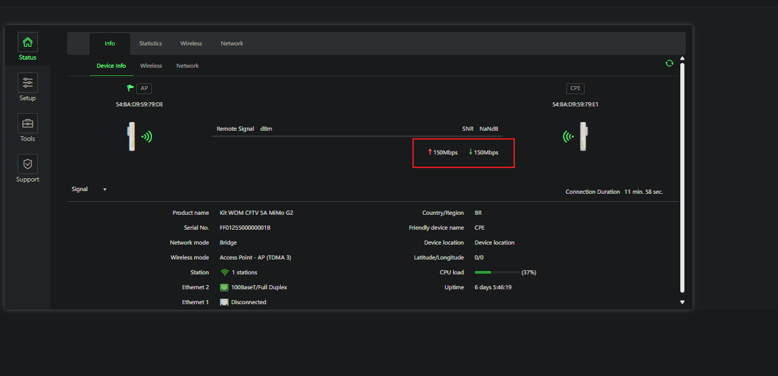
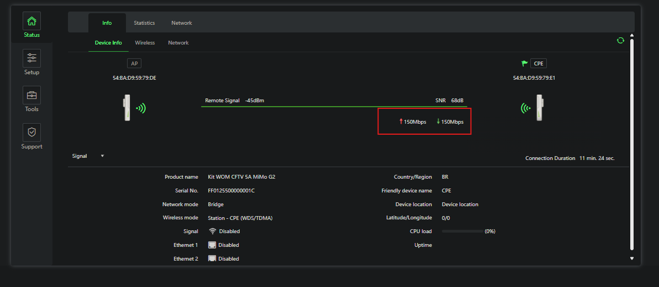
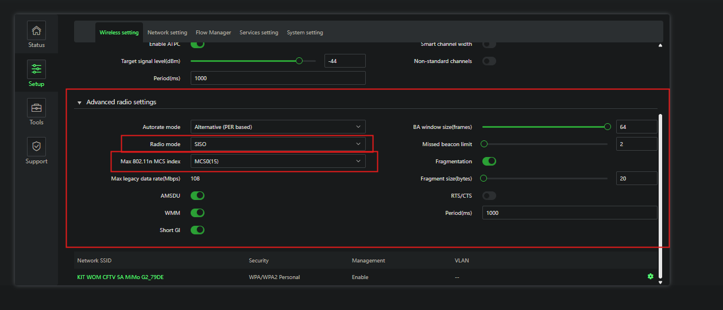

- Conclusion
Throughput connection isn’t respecting the data rate of the MCS defined
- Photos
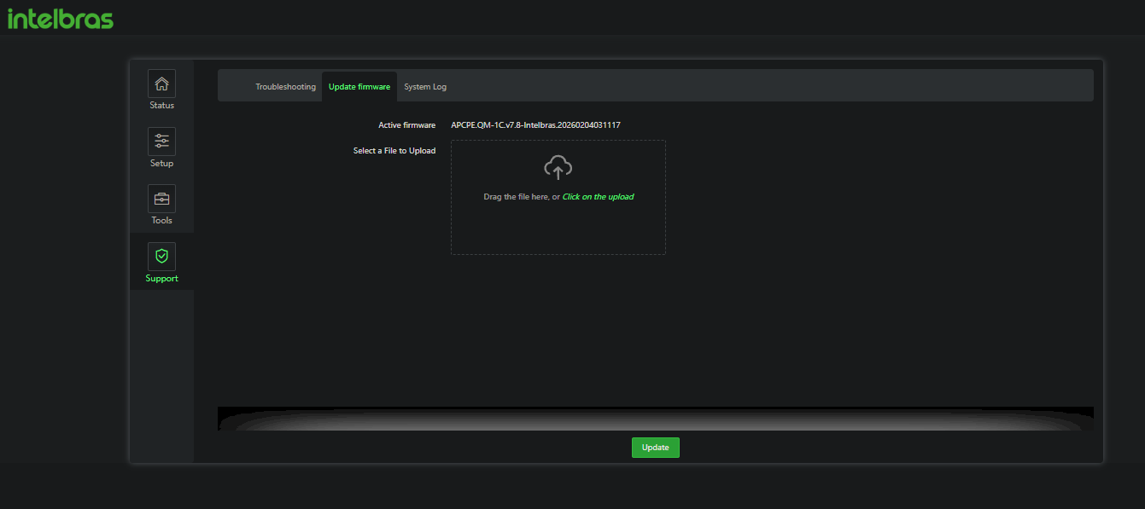

  - TC-01
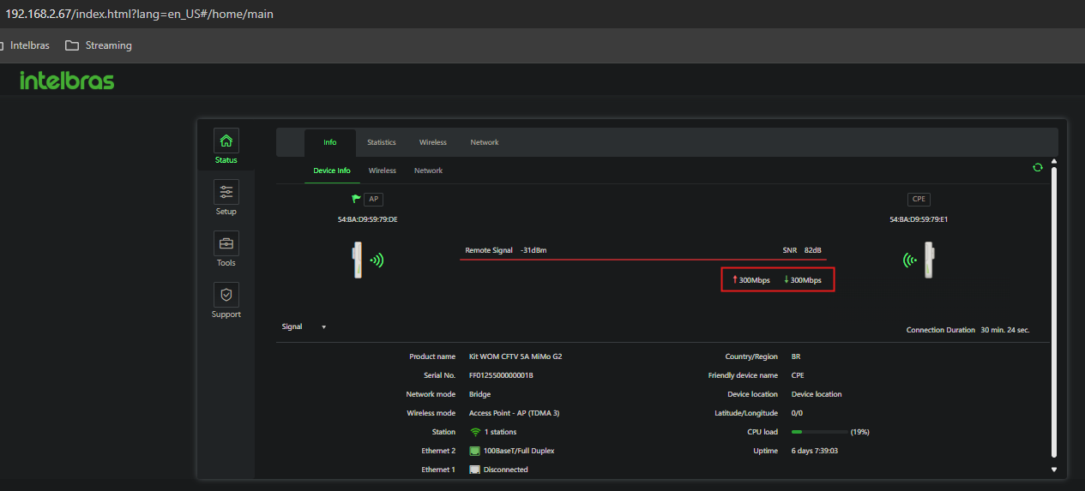
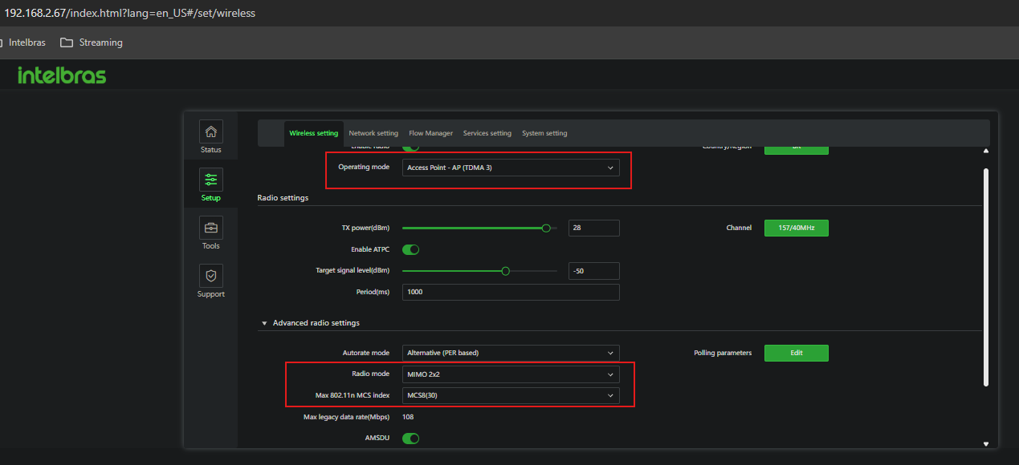
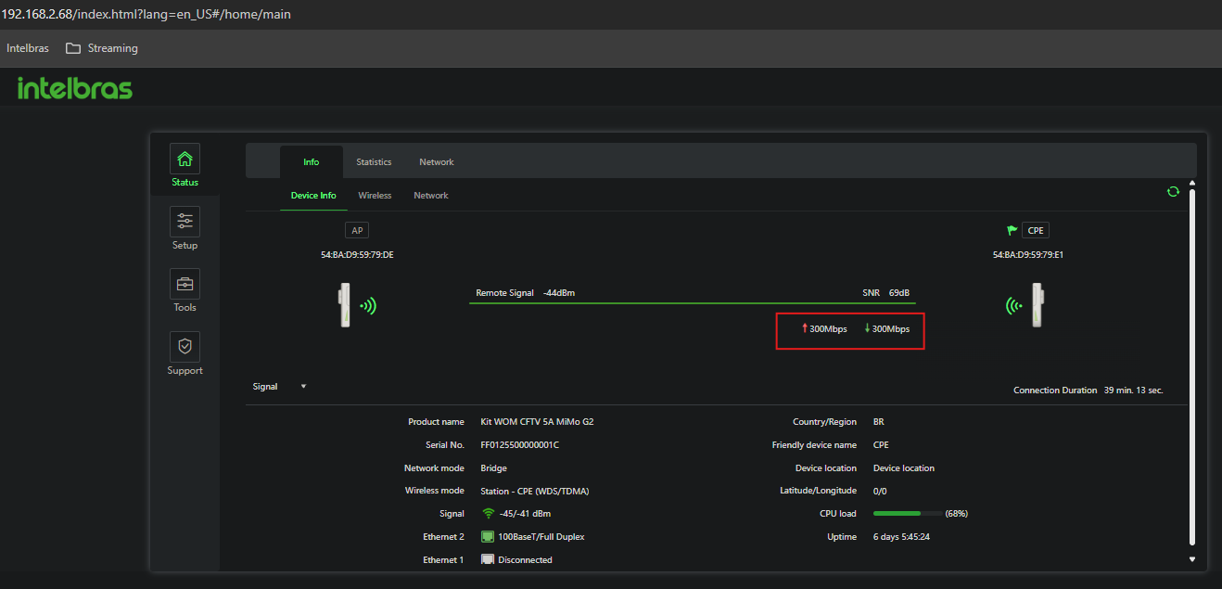
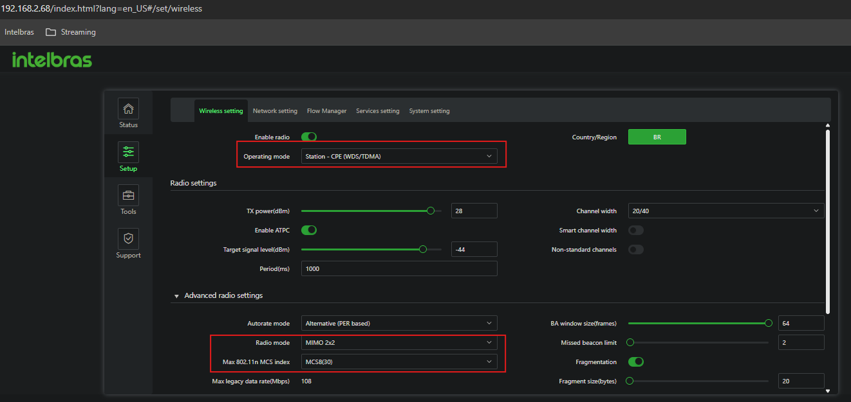
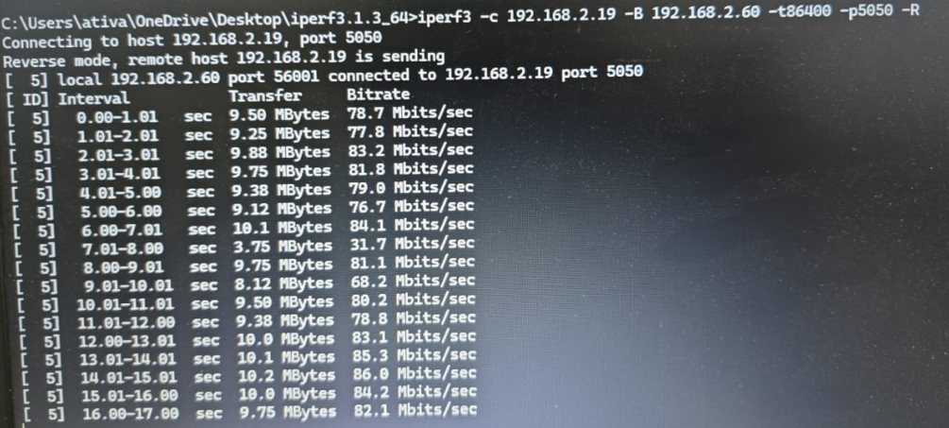
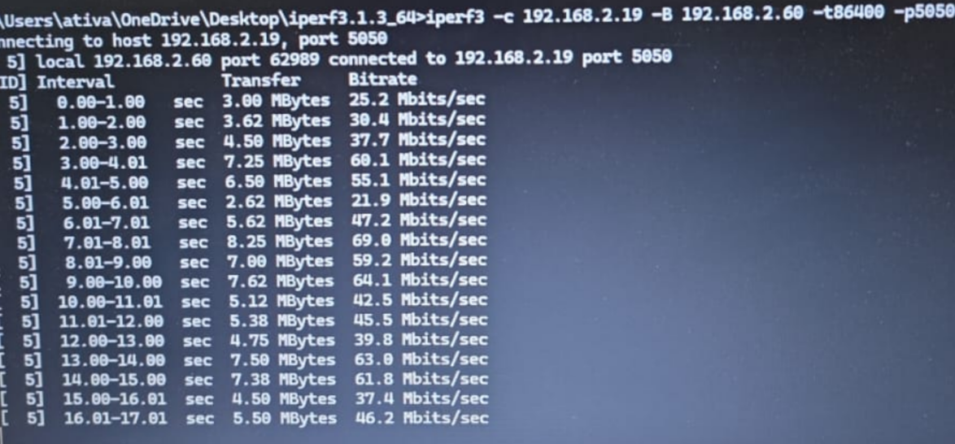

  - TC-02
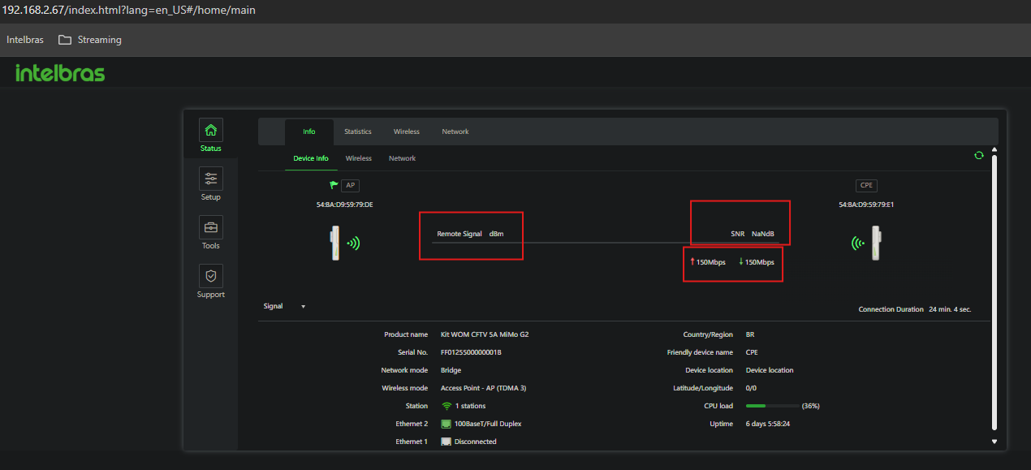
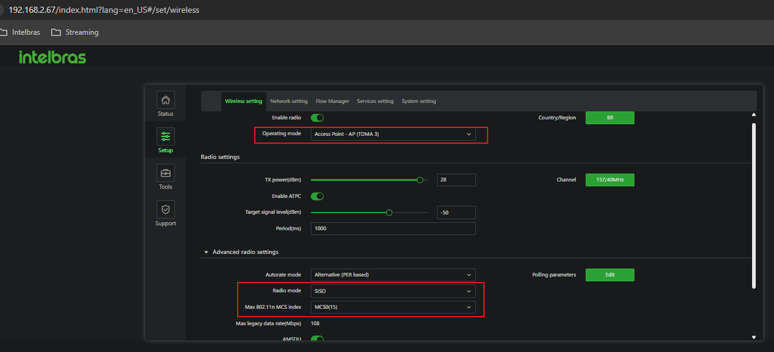
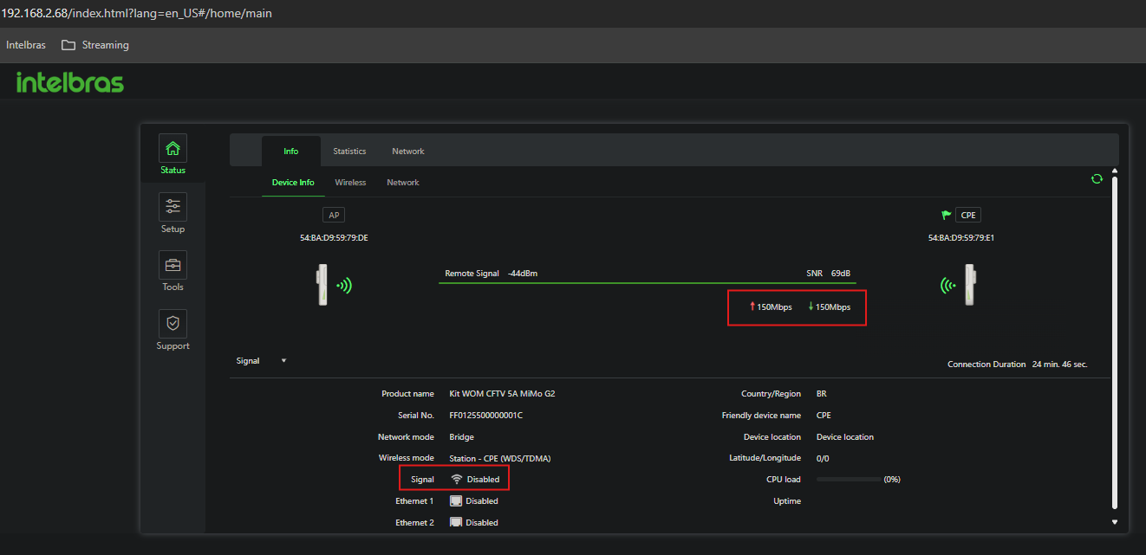
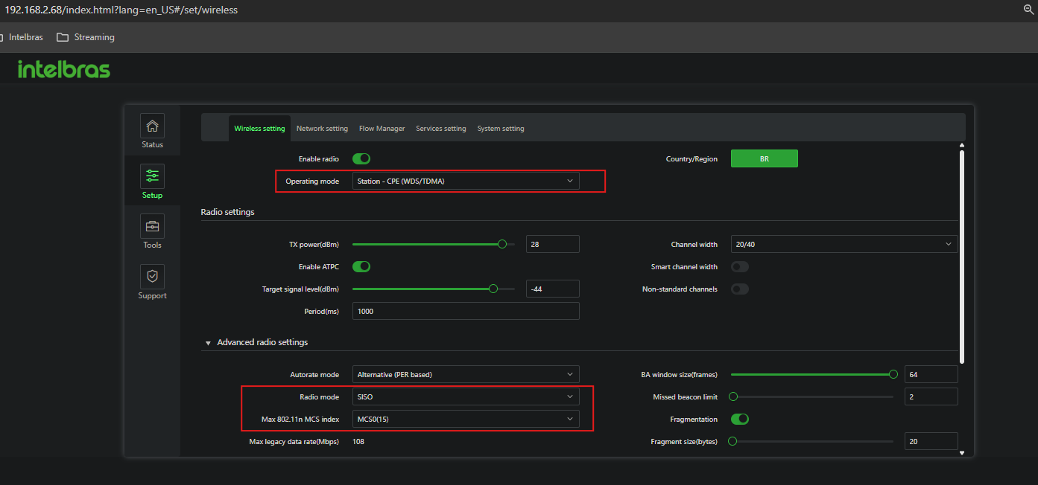
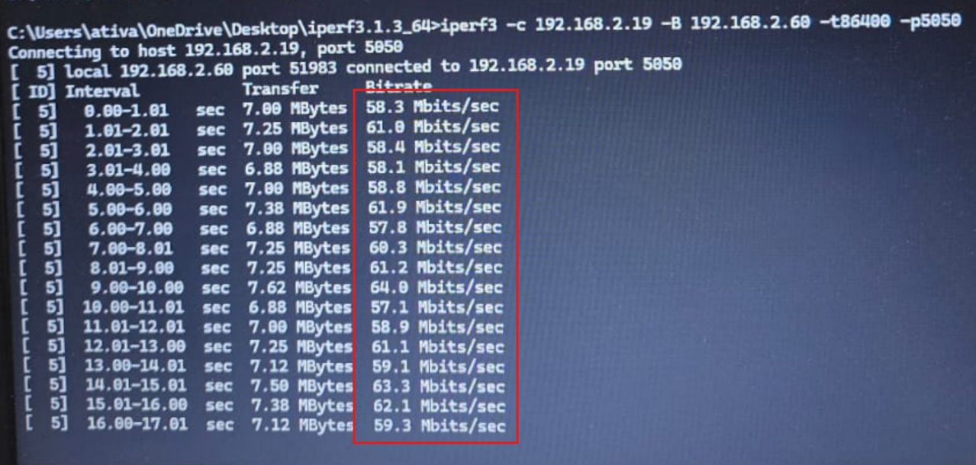



___________________________________
Gabriel Dias dos Santos - Reliability Analyst

